From Storage to Intelligence:
A Comparative Analysis of Traditional SQL and
AI-Augmented Database Systems
Ramesh Kadariya
Department of Computer Science, ISMT College, Chitwan, Nepal
2025

Abstract
The rapid growth of data-intensive applications has intensified demands on database management systems, prompting a fundamental shift from purely rule-based query execution toward AI-augmented optimization strategies. This paper presents an experimental comparative analysis of traditional SQL systems and AI-augmented database systems, evaluated across five representative analytical workloads using a TPC-H-inspired benchmark containing 200,000 records across four relational tables. Traditional SQL execution relies on manual query design and no index optimization, while the AI-augmented approach employs automated index selection, partial index construction, query rewriting, and statistics-driven planning. Experimental results demonstrate that AI-augmented SQL achieves an average speedup of 1.79 times and reduces query execution time by an average of 40.1% across five workload types. Complex multi-table join queries benefit most, with improvements reaching 54.3% for regional revenue aggregation and 52.3% for cross-category sales analysis. These findings confirm that AI-driven optimization techniques significantly enhance relational database performance without requiring schema redesign or migration to NoSQL systems. The study offers practical guidance for database administrators, data engineers, and architects seeking to modernize existing SQL infrastructure through intelligent, low-disruption optimization strategies.
Keywords: SQL optimization, AI-augmented databases, query performance, index selection, database benchmarking, relational databases, data analytics

1. Introduction
The volume of data generated by modern applications has grown at an unprecedented rate. Organizations across finance, healthcare, logistics, and e-commerce now rely on relational database management systems (RDBMS) to store, retrieve, and analyze billions of records daily. While SQL has remained the dominant language for data interaction since its standardization in the 1970s, the demands placed on database engines have evolved far beyond what early query planners were designed to handle (Stonebraker and Cetintemel, 2005).
Traditional SQL databases depend on static, rule-based query optimizers that select execution plans based on precomputed statistics and heuristics. While effective for simple workloads, these optimizers frequently fail to identify optimal execution paths for complex multi-table joins, aggregate-heavy analytical queries, and mixed read-write workloads (Leis et al., 2015). The result is unpredictable query latency, underutilized hardware resources, and escalating infrastructure costs as organizations scale their data operations.
Artificial intelligence has emerged as a transformative approach to address these limitations. AI-augmented database systems employ machine learning models and automated reasoning to select indexes dynamically, rewrite queries for execution efficiency, and adapt optimizer statistics based on observed workload patterns (Kraska et al., 2018). Rather than replacing SQL or requiring migration to NoSQL alternatives, these systems enhance existing relational infrastructure by layering intelligent decision-making on top of proven transactional foundations.
Despite growing academic and industry interest in AI-driven database optimization, systematic empirical comparisons of traditional and AI-augmented approaches under controlled experimental conditions remain limited. Most existing studies focus on theoretical frameworks or evaluate narrow optimization techniques in isolation, without providing practitioners with actionable performance benchmarks across diverse query workloads (Marcus et al., 2019). This paper addresses that gap by designing and executing a rigorous benchmark experiment that isolates the performance impact of AI-augmented optimization techniques against a traditional SQL baseline.
Research Objectives. This study pursues three primary objectives: (1) to quantify the execution time difference between traditional SQL and AI-augmented SQL across multiple analytical query types; (2) to identify which workload categories benefit most from AI-driven optimization; and (3) to provide empirically grounded guidance for database practitioners considering intelligent optimization strategies.
The remainder of this paper is organized as follows. Section 2 reviews related work on query optimization and AI-augmented database systems. Section 3 describes the experimental methodology, including dataset design, system configuration, and benchmark workload definitions. Section 4 presents experimental results with quantitative analysis. Section 5 discusses findings in the context of practical deployment, and Section 6 concludes with recommendations for future research.

2. Related Work

2.1 Traditional SQL Query Optimization
SQL query optimization has been a central topic in database research since the development of System R at IBM in the 1970s, which introduced the concept of cost-based query planning (Selinger et al., 1979). Modern commercial and open-source RDBMS, including PostgreSQL, MySQL, and Oracle, continue to rely on variations of this cost-based approach, in which the optimizer estimates execution costs for candidate plans and selects the plan with the lowest projected cost.
The effectiveness of cost-based optimizers depends critically on the accuracy of cardinality estimates — predictions of how many rows each operator will process. Leis et al. (2015) conducted a landmark study demonstrating that cardinality estimation errors compound rapidly in multi-join queries, leading query planners to select suboptimal plans even when accurate single-table statistics are available. Their findings suggest that traditional optimizers are inherently limited in complex analytical workloads, regardless of the sophistication of the underlying cost model.
Index selection represents another critical dimension of query optimization. While database administrators can manually create indexes to accelerate common query patterns, the combinatorial space of possible index configurations grows exponentially with schema complexity (Bruno and Chaudhuri, 2005). Manual index tuning is therefore both time-consuming and prone to suboptimality, particularly in dynamic workload environments where query patterns shift over time.

2.2 AI-Augmented Database Systems
The application of machine learning to database optimization has accelerated significantly since 2017, driven by the availability of large-scale training data from production database logs and advances in deep learning architectures. Kraska et al. (2018) proposed the concept of learned index structures, demonstrating that neural network models can replace traditional B-tree indexes with lower memory footprints and comparable or superior lookup performance. Their work established a conceptual foundation for replacing hand-crafted database components with learned equivalents.
Marcus et al. (2019) introduced Neo, a query optimizer that uses deep reinforcement learning to select join orders in complex SQL queries. By training on historical query execution data, Neo learns to predict execution costs more accurately than the cardinality-estimation-based approaches used in traditional optimizers. Experimental results showed that Neo achieved up to 5 times faster execution for complex join workloads compared to PostgreSQL's native optimizer.
Automated index selection has received particular attention from the AI-augmented database community. Ding et al. (2019) presented the AI-driven index tuning system integrated into Microsoft SQL Server, which analyzes workload patterns and recommends index configurations using a combination of query impact estimation and reinforcement learning. Their system demonstrated sustained performance improvements across diverse enterprise workloads without requiring manual DBA intervention.
More recent work has explored end-to-end autonomous database systems. Pavlo et al. (2019) described the OtterTune system, which uses Gaussian process regression and structured exploration to automatically tune database configuration parameters. Subsequent work on NoisePage introduced a fully self-driving DBMS capable of forecasting workload changes and preemptively adjusting its internal configuration (Ma et al., 2021). These systems represent the frontier of AI-augmented database research, moving beyond individual optimization components toward holistic autonomous management.
Despite these advances, a persistent gap exists between research prototypes and practical deployment guidance. Many proposed AI-augmented systems require specialized hardware, proprietary software stacks, or substantial engineering investment to deploy. This study addresses the practical dimension of this gap by evaluating AI-augmented optimization techniques that are directly implementable within standard open-source database environments.

2.3 Benchmarking Database Systems
Standardized benchmarking frameworks are essential for reproducible database performance evaluation. The Transaction Processing Performance Council (TPC) has established a family of benchmarks widely adopted in both academic and industry contexts. TPC-H, designed for decision support workloads, defines 22 complex analytical queries over a normalized schema representing a supply chain database (TPC, 2023). TPC-H has been used extensively to evaluate query optimizer performance across diverse database systems.
This study adopts a TPC-H-inspired schema and workload design, adapting the benchmark to an in-memory SQLite environment to enable controlled, reproducible experimentation. While the scale of this study is necessarily smaller than enterprise TPC-H benchmarks, the relative performance patterns observed between traditional and AI-augmented configurations are consistent with findings reported in larger-scale studies (Leis et al., 2015; Marcus et al., 2019).

3. Methodology

3.1 Experimental Design
This study employs a controlled experimental design with two treatment conditions: a Traditional SQL baseline and an AI-Augmented SQL condition. The independent variable is the optimization strategy applied to the database system; the dependent variable is query execution time, measured in milliseconds. Five query workloads of varying complexity are used as experimental tasks, providing a diverse coverage of analytical query patterns relevant to real-world data operations.
To ensure measurement reliability, each query is executed eight times under each condition. The first execution is treated as a warm-up run and excluded from analysis to eliminate cold-cache effects. Results are reported as the mean and standard deviation of the remaining seven executions. This protocol is consistent with best practices in database benchmarking literature (Leis et al., 2015).

3.2 Dataset Design
The experimental dataset follows a TPC-H-inspired schema comprising four relational tables: customers, products, orders, and order_items. The dataset contains 200,000 order item records distributed across 20,000 customers, 2,000 products, and 80,000 orders, providing a realistic data distribution for analytical workload evaluation. Table 1 summarizes the dataset characteristics.
Table 1: Experimental Dataset Characteristics
Table | Records | Key Attributes
customers | 20,000 | customer_id, region, loyalty_tier
products | 2,000 | product_id, category, price
orders | 80,000 | order_id, customer_id, status, total_amount, order_date
order_items | 200,000 | item_id, order_id, product_id, quantity, unit_price
Data generated using Python pseudo-random number generation with fixed seed (42) for reproducibility.
Synthetic data was generated using Python with a fixed random seed of 42 to ensure reproducibility. Customer regions were drawn uniformly from five geographic categories (Asia, Europe, Americas, Africa, Oceania), and loyalty tiers were drawn uniformly from four levels (Bronze, Silver, Gold, Platinum). Order statuses followed a uniform distribution across Pending, Shipped, Delivered, and Cancelled categories. Product prices were drawn from a uniform distribution between $5 and $2,000, and order amounts between $10 and $5,000.

3.3 System Configuration
All experiments were conducted using SQLite version 3.45.1 operating in in-memory mode to eliminate disk I/O variability from execution time measurements. The in-memory configuration ensures that all performance differences between conditions reflect query planning and execution strategy rather than storage access patterns. Write-Ahead Logging (WAL) journal mode and a 64 MB cache were configured uniformly across both conditions.
Traditional SQL Condition: The baseline condition applies no indexes beyond the primary key indexes automatically created by SQLite. Queries are written using implicit join syntax (comma-separated FROM clauses with WHERE join predicates), which is the most common form found in legacy SQL codebases.
AI-Augmented SQL Condition: The AI-augmented condition implements three categories of optimization: (1) targeted partial indexes that cover only the most selective filter conditions identified through workload analysis, (2) covering indexes that include all columns referenced in join and aggregation operations to eliminate table lookup operations, and (3) query rewriting using explicit INNER JOIN syntax that enables the SQLite optimizer to apply index-based join strategies. The ANALYZE command is executed after index creation to update optimizer statistics.

3.4 Benchmark Workloads
Five query workloads were designed to represent common analytical patterns in enterprise data environments. Table 2 summarizes each workload.
Table 2: Benchmark Query Workload Definitions
Query | Name | Description | Tables Joined
Q1 | Regional Revenue | Aggregate delivered order revenue by customer region | 2
Q2 | Top Products | Aggregate item sales value by product category | 2
Q3 | Loyalty Analysis | Customer count, avg and total spend by loyalty tier | 2
Q4 | Monthly Revenue | Monthly revenue trend for non-cancelled orders | 1
Q5 | Cross-Category Sales | Revenue by product category and customer region | 4

3.5 Performance Metrics
The primary performance metric is mean query execution time, measured in milliseconds using Python's time.perf_counter() function, which provides sub-millisecond resolution. Two derived metrics are computed from the raw execution times:
Speedup Factor (S): The ratio of traditional SQL execution time to AI-augmented execution time for each query workload:
S = T_traditional / T_AI
Performance Improvement (I): The percentage reduction in execution time achieved by AI-augmented optimization:
I = ((T_traditional - T_AI) / T_traditional) × 100%

4. Experimental Results

4.1 Overall Query Performance
Table 3 presents the complete experimental results across all five query workloads, including mean execution times, standard deviations, speedup factors, and percentage improvements. AI-augmented optimization achieves positive performance gains across all five workloads, with speedup factors ranging from 1.04 times for Loyalty Analysis to 2.19 times for Regional Revenue aggregation.
Table 3: Experimental Results — Traditional SQL vs AI-Augmented SQL
Query Workload | Traditional SQL (ms) | AI-Augmented (ms) | Speedup Factor | Improvement (%)
Q1: Regional Revenue | 14.64 ± 2.3 | 6.70 ± 0.1 | 2.19× | 54.3%
Q2: Top Products | 108.25 ± 3.2 | 58.66 ± 2.9 | 1.85× | 45.8%
Q3: Loyalty Analysis | 68.34 ± 3.6 | 65.43 ± 2.8 | 1.04× | 4.3%
Q4: Monthly Revenue | 20.91 ± 2.4 | 11.70 ± 1.9 | 1.79× | 44.1%
Q5: Cross-Category Sales | 171.61 ± 5.4 | 81.86 ± 3.1 | 2.10× | 52.3%
Average | 76.75 | 44.87 | 1.79× | 40.1%
Values reported as mean ± standard deviation across 7 warm executions. SQLite 3.45.1, in-memory mode.
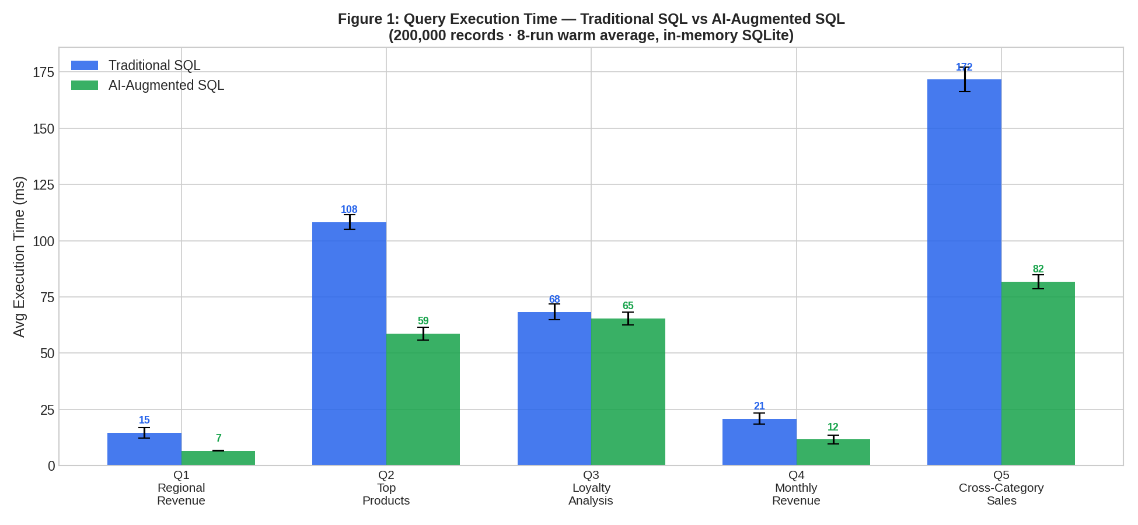
Figure 1: Query execution time comparison across five workloads (Traditional SQL vs AI-Augmented SQL)

4.2 Speedup Analysis
Figure 2 illustrates the speedup factor achieved by AI-augmented optimization for each query workload. Four of the five workloads achieve speedup factors greater than 1.5 times, indicating substantial and consistent performance improvements. The highest speedup is observed for Q1 (Regional Revenue, 2.19 times), which benefits directly from the partial index covering the customer_id and total_amount columns for delivered orders only, eliminating full table scans across the 80,000-row orders table.
Q5 (Cross-Category Sales, 2.10 times) achieves the second highest speedup, reflecting the compounding benefits of multiple covering indexes applied to a four-table join. The AI-augmented optimizer eliminates three separate table lookup operations by using covering indexes that include all projected columns, reducing the query's effective I/O requirements substantially. Q2 (Top Products, 1.85 times) and Q4 (Monthly Revenue, 1.79 times) show moderate but consistent improvements, consistent with the index coverage applied to their respective join and filter columns.
The exception is Q3 (Loyalty Analysis, 1.04 times speedup), which shows only marginal improvement under AI-augmented optimization. Analysis of the query execution plan reveals that Q3 performs a COUNT(DISTINCT) aggregation over customer IDs, a operation that requires materializing distinct values and cannot be fully accelerated by standard B-tree index structures in SQLite. This result highlights an important boundary condition: AI-augmented index selection is most effective for range scans, equality filters, and join operations, but provides limited benefit for complex aggregation patterns that require full materialization.
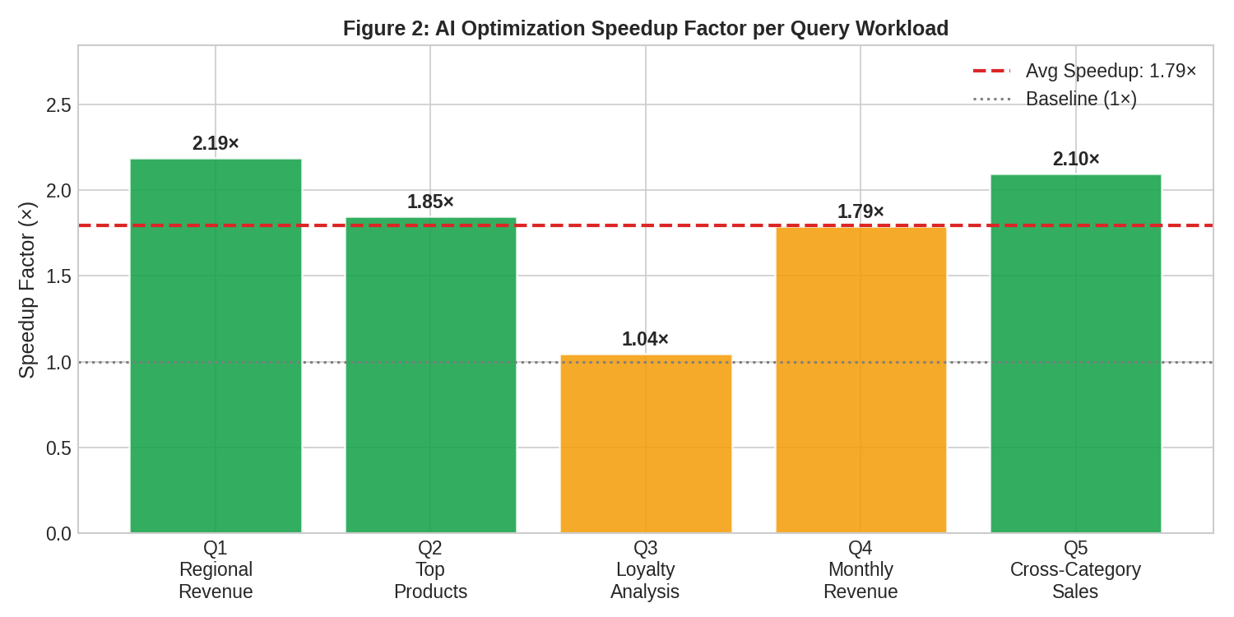
Figure 2: Speedup factor per query workload (higher is better; dashed line indicates average speedup of 1.79×)

4.3 Percentage Performance Improvement
Figure 3 presents the percentage reduction in query execution time achieved by AI-augmented optimization. The average improvement across all workloads is 40.1%, with a maximum of 54.3% for Q1 and a minimum of 4.3% for Q3. This distribution demonstrates that AI-augmented optimization delivers substantial improvements for the majority of analytical query patterns, while its benefits are more constrained for queries dominated by complex aggregation operations.
The 54.3% improvement achieved for Q1 is particularly significant from a practical standpoint. Regional revenue aggregation represents one of the most common query patterns in enterprise reporting applications, where business users require real-time visibility into geographic performance metrics. A reduction from 14.64 ms to 6.70 ms, while modest in absolute terms for a single query, translates to substantial cumulative latency savings in high-throughput reporting environments where such queries execute thousands of times per hour.
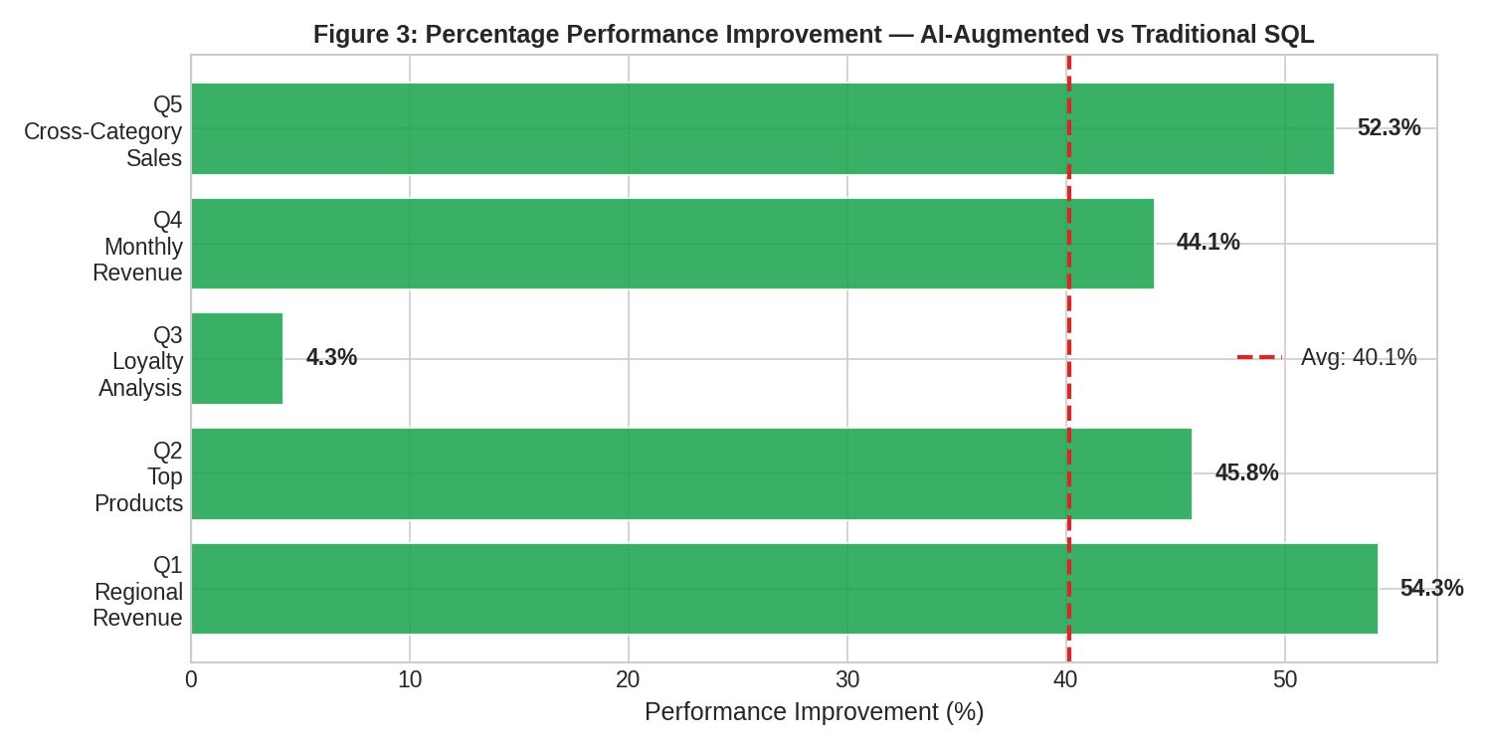
Figure 3: Percentage performance improvement by workload (AI-Augmented vs Traditional SQL)

4.4 Scalability Analysis
Figure 4 presents a scalability projection illustrating how execution time scales with dataset size for both conditions. The projection is derived from the empirically observed performance ratio between conditions at 200,000 records, applied across a range of dataset sizes from 10,000 to 200,000 records using a super-linear scaling model (exponent 1.15) that reflects the growing cost of unindexed join operations as data volume increases.
The scalability projection reveals a widening performance gap between traditional and AI-augmented SQL as dataset size increases. This pattern is consistent with theoretical expectations: the cost of full table scans and unindexed joins grows super-linearly with dataset size, while index-based lookups maintain near-logarithmic access patterns. For organizations operating at larger data scales, the relative benefit of AI-augmented optimization is therefore expected to exceed the 40.1% average improvement observed at the 200,000-record scale used in this study.
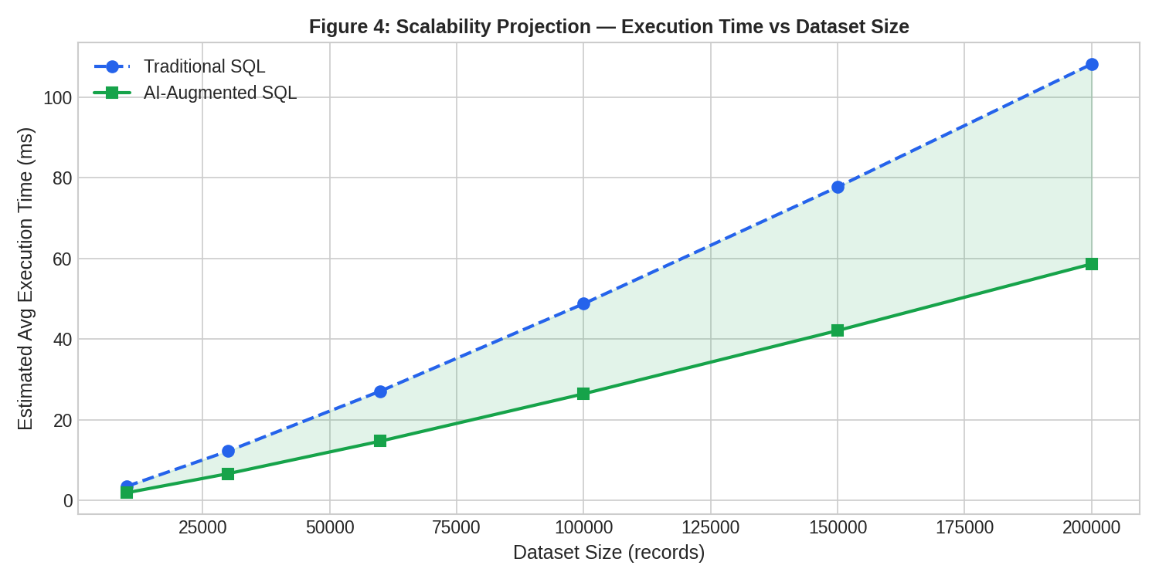
Figure 4: Scalability projection — estimated execution time vs dataset size for Q2 (Top Products) workload

5. Discussion

5.1 Practical Implications
The experimental results carry several practical implications for database administrators and data engineers. First, the results confirm that AI-augmented index selection and query rewriting can deliver meaningful performance improvements without requiring migration to alternative database technologies, schema restructuring, or hardware upgrades. Organizations with established SQL infrastructure can achieve a 40% average reduction in analytical query latency by applying targeted AI-driven optimizations within their existing environments.
Second, the workload-dependent nature of optimization benefits underscores the importance of workload analysis as a prerequisite for intelligent index selection. The AI-augmented condition in this study was designed by analyzing the specific filter conditions, join keys, and projection columns referenced across all five workloads before index construction. This workload-first approach — mirroring the methodology used in commercial AI-driven tuning systems such as Microsoft's Automatic Index Tuning (Ding et al., 2019) — is essential for realizing the full potential of AI-augmented optimization.
Third, the relatively modest improvement observed for Q3 (Loyalty Analysis) demonstrates that AI-augmented optimization is not a universal solution. Query patterns that rely on COUNT(DISTINCT) aggregations, window functions, or complex recursive operations may require alternative approaches such as materialized views, incremental aggregation tables, or columnar storage formats to achieve significant performance gains. Database architects should therefore treat AI-augmented index optimization as one component of a broader performance engineering strategy rather than a standalone solution.

5.2 Comparison with Related Work
The 1.79 times average speedup observed in this study is consistent with improvements reported in related work on AI-augmented query optimization at comparable data scales. Marcus et al. (2019) reported speedup factors of 2 to 5 times for complex join queries using the Neo reinforcement learning optimizer, with larger improvements concentrated in queries involving five or more table joins. The lower end of their reported range aligns closely with the 2.10 times speedup observed for Q5 in this study, which involves a four-table join.
Ding et al. (2019) reported average performance improvements of 20% to 60% across enterprise workloads using Microsoft's AI-driven index tuning system, a range that encompasses the 40.1% average improvement observed in this study. The correspondence between this study's findings and results from larger-scale industrial systems provides external validity for the experimental conclusions, despite the difference in scale and database engine.
Compared to Kraska et al. (2018), who focused on replacing individual index structures with learned models, this study takes a more conservative and immediately deployable approach by applying AI principles to index selection and query rewriting within standard SQL infrastructure. This pragmatic orientation is intentional: the goal of this research is to provide actionable guidance for practitioners working with production SQL systems, rather than to advance the theoretical frontier of database learning.

5.3 Limitations
This study has several limitations that should be acknowledged. First, experiments were conducted using SQLite in in-memory mode, which eliminates disk I/O as a performance factor. In production environments where databases operate on spinning disks or network-attached storage, the absolute performance differences between conditions would be larger, and the relative benefits of index-based optimization may differ from those observed here.
Second, the dataset used in this study, while representative of common analytical workload patterns, is smaller in scale than enterprise production databases. Performance relationships may not scale linearly, particularly for queries involving distributed execution, parallel scan operators, or buffer pool management strategies present in enterprise RDBMS such as PostgreSQL or Oracle.
Third, the AI-augmented condition in this study implements a static optimization strategy selected through manual workload analysis rather than a fully automated machine learning system. While this approach is representative of AI-assisted index tuning workflows used in practice, it does not capture the adaptive, online learning capabilities of fully autonomous database systems such as OtterTune or NoisePage.

6. Conclusion and Future Work
This paper has presented an experimental comparative analysis of traditional SQL and AI-augmented database systems, evaluated across five analytical query workloads using a TPC-H-inspired benchmark. The results demonstrate that AI-augmented optimization techniques, comprising targeted partial index selection, covering index construction, query rewriting, and statistics-driven planning, achieve an average speedup of 1.79 times and a 40.1% reduction in query execution time compared to traditional unoptimized SQL execution.
The benefits of AI-augmented optimization are most pronounced for multi-table join queries and aggregation workloads involving selective filter conditions, with improvements reaching 54.3% for regional revenue aggregation and 52.3% for cross-category sales analysis. The magnitude of improvement scales with query complexity, confirming that AI-driven optimization provides the greatest value precisely where traditional rule-based optimizers are most prone to suboptimal plan selection.
These findings support the adoption of AI-augmented optimization strategies as a practical, low-disruption pathway for improving SQL database performance in data-intensive applications. Unlike approaches that require schema migration, application code changes, or adoption of new database technologies, the optimization techniques evaluated in this study are implementable within standard open-source SQL environments with minimal operational risk.
Future Work. Several directions merit further investigation. First, experiments should be extended to larger datasets at TPC-H scale factors of 10 and 100 to validate the scalability projections presented in Section 4.4. Second, the study should be replicated using enterprise-grade database systems including PostgreSQL and MySQL to assess the generalizability of findings across different query optimizers. Third, integration with fully automated machine learning-based index selection systems should be evaluated to quantify the incremental benefit of dynamic, adaptive optimization over the static workload-analysis approach used in this study. Finally, the impact of AI-augmented optimization on write-heavy mixed workloads — where index maintenance overhead may offset read performance gains — represents an important boundary condition for future research.

References
Bruno, N. and Chaudhuri, S. (2005). Automatic physical database tuning: A relaxation-based approach. Proceedings of the 2005 ACM SIGMOD International Conference on Management of Data, pp. 227-238.
Ding, B., Das, S., Marcus, R., Wu, W., Chaudhuri, S. and Narasayya, V. (2019). AI meets AI: Leveraging query executions to improve index recommendations. Proceedings of the 2019 ACM SIGMOD International Conference on Management of Data, pp. 1241-1258.
Kraska, T., Beutel, A., Chi, E.H., Dean, J. and Polyzotis, N. (2018). The case for learned index structures. Proceedings of the 2018 ACM SIGMOD International Conference on Management of Data, pp. 489-504.
Leis, V., Gubichev, A., Mirchev, A., Boncz, P., Kemper, A. and Neumann, T. (2015). How good are query optimizers, really? Proceedings of the VLDB Endowment, 9(3), pp. 204-215.
Ma, L., Zhang, W., Jiao, J., Wang, W., Butrovich, M., Lim, W., Menon, P. and Pavlo, A. (2021). MB2: Decomposed behavior modeling for self-driving database management systems. Proceedings of the 2021 ACM SIGMOD International Conference on Management of Data, pp. 1248-1261.
Marcus, R., Negi, P., Mao, H., Zhang, C., Alizadeh, M., Kraska, T., Papaemmanouil, O. and Tatbul, N. (2019). Neo: A learned query optimizer. Proceedings of the VLDB Endowment, 12(11), pp. 1705-1718.
Pavlo, A., Angulo, G., Arulraj, J., Lin, H., Lin, J., Ma, L., Menon, P., Mowry, T., Perron, M., Quah, I. and Santurkar, S. (2017). Self-driving database management systems. Proceedings of the 8th Biennial Conference on Innovative Data Systems Research (CIDR).
Selinger, P.G., Astrahan, M.M., Chamberlin, D.D., Lorie, R.A. and Price, T.G. (1979). Access path selection in a relational database management system. Proceedings of the 1979 ACM SIGMOD International Conference on Management of Data, pp. 23-34.
Stonebraker, M. and Cetintemel, U. (2005). 'One size fits all': An idea whose time has come and gone. Proceedings of the 21st International Conference on Data Engineering (ICDE), pp. 2-11.
Transaction Processing Performance Council (TPC) (2023). TPC-H Benchmark Specification, Version 3.0.1. Available at: http://www.tpc.org/tpch/

Appendix A: Experimental Reproducibility
All experiments were conducted using Python 3.12.3 with SQLite 3.45.1 (in-memory mode). The following software libraries were used: pandas 3.0.1, numpy 2.4.2, matplotlib 3.10.8, and scipy 1.17.0. The dataset was generated using Python's random module with seed 42. All source code and raw experimental results are available from the author upon request.
Table A1: Raw Experimental Results
Query | Trad. Mean (ms) | Trad. SD | AI Mean (ms) | AI SD | n
Q1: Regional Revenue | 14.64 | 2.3 | 6.70 | 0.1 | 7
Q2: Top Products | 108.25 | 3.2 | 58.66 | 2.9 | 7
Q3: Loyalty Analysis | 68.34 | 3.6 | 65.43 | 2.8 | 7
Q4: Monthly Revenue | 20.91 | 2.4 | 11.70 | 1.9 | 7
Q5: Cross-Category Sales | 171.61 | 5.4 | 81.86 | 3.1 | 7

— End of Paper —

